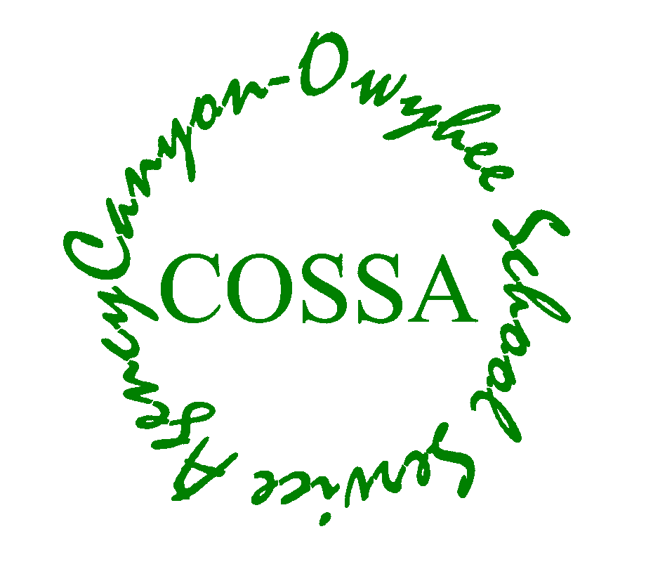
CANYON-OWYHEE SCHOOL SERVICE AGENCY
109 Penny Lane
Wilder, ID 83676
Phone (208) 482-6074
Fax (208) 482-7904

COSSA
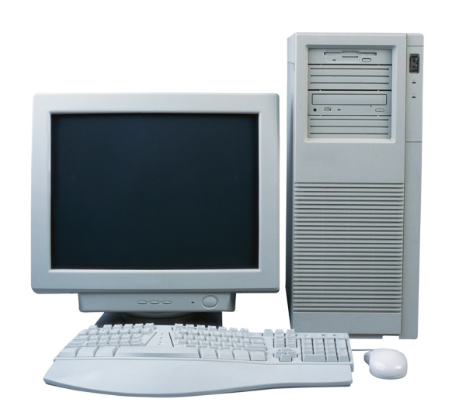
Information Technology Plan
(Effective December 17, 2018)

Canyon-Owyhee School Service Agency (COSSA) is a public school cooperative serving the special education, gifted/talented, Career-technical, and alternative education needs of students from Homedale, Marsing, Notus, Parma, and Wilder School Districts.
Table of Contents

Table of Contents 2

Technology Action Plans 3

Technology Professional Development 6

Goals for Student Use of Technology 8

Grade Level Proficiency Standards for Technology Education 11

COSSA INFORMATION TECHNOLOGY PLAN
Created 2018-2019 School Year

1. Technology Action Plans. COSSA has Technology Action Plans in the areas of infrastructure, hardware, software, and hand-held communications. The following tables detail the actions necessary in each area.

Infrastructure

Goals:

1. Upgrade Internet broadband service to CRTEC to a minimum of 350 Mbps

2. Extend IT services to remote locations such as the COSSA Day Care.

3. Replace ENA Wi-Fi equipment in CRTEC with newer equipment that provides better coverage within the building.

Objectives:

1. Create an alternative to Frontier Communications for delivery of land-line Internet service to CRTEC by installing a new landline funded under the SDE’s Broadband Expansion Initiative.

2. Expand Wi-Fi to COSSA Day Care building and Residential Construction modular classroom
Activities | Responsible | Timeframe | Resources
1. Tek-Hut install a microwave antenna for temporary delivery of Internet to CRTEC  2. Shift Internet from Frontier Communications to new landline installed by Tek-Hut  3. Tek-Hut install upgraded Wi-Fi in CRTEC | 1. Tek-Hut  2. COSSA  3. Tek-Hut | 1. Summer, 2018  2. Fall, 2018  3. Fall, 2018 | 1. Tek-Hut provided microwave antenna  2. SDE Broadband Initiative funds, Tek-Hut installation  3. Existing (inadequate) Wi-Fi in CRTEC

Hardware

Goal:

1. Robust, redundant, Internet and server system in CRTEC

2. Adequate hardware (computers, printers, scanners, etc) for Special Education/Gifted and Talented COSSA employees

Objectives:

1. All critical systems have UPS and backup power, including servers, routers, and switches

2. All susceptible electronics (computers, filters, telecommunications, Wi-Fi, routers, Internet switches) are surge protected

3. All critical data (Admin server, student-teacher server) is automatically backed up and safeguarded

4. All computer hardware is obsolesced and rotated out at appropriate intervals (CRTEC)

5. Replacement of obsolete computers, printers, etc, at consortium district buildings is coordinated with those district’s IT personnel
Activities | Responsible | Timeframe | Resources
1. Verify adequate UPS for servers, filters, routers, telephones, alarms, etc  2. Verify adequate surge protection for all telecommunication equipment, Wi-Fi devices, computers, routers, and Internet switches  3. Create a remote-site data safeguard system for all server data  4. Create a hardware obsolescence plan for all computers, including those at consortium districts that COSSA owns | 1. IT Coordinator  2. Tek-Hut  3. IT Coordinator and Business Manager  4. IT Coordinator and Director | 1. Fall, 2018  2. Fall, 2018  3. Fall, 2018  4. Fall, 2018 | 1. Most equipment in the telecommunications room already have UPS  2. Most electronic equipment already has surge protection – but not all  3. Rudimentary remote-site data back-up in place  4. Most computers are already well past normal obsolescence date

Software

Goal: All COSSA employees have all software programs necessary to do their jobs

Objectives:

1. All necessary software programs are installed where needed – software inventory in all program areas complete and fully supported

2. As part of software inventory, ensure that no unnecessary or malicious software is installed on any CRTEC computer or network

3. A “filter” program is installed and operational to ensure students are not on inappropriate sites in CRTEC

4. A student computer monitoring program installed and operational in CRTEC
Activities | Responsible | Timeframe | Resources
1. Inventory existing hardware and software so that IT Coordinator knows what we really have  2. Based on software inventory create a catalog of all software and when it must be upgraded  3. Unload any unnecessary software from any COSSA computers | 1. IT Coordinator  2. IT Coordinator  3. IT Coordinator | 1. February, 2014  2. May, 2014  3. May, 2014 | 1. Students performing projects, maintenance personnel, DOL paid personnel  2. Students performing projects, maintenance personnel, DOL paid personnel  3. Students performing projects, maintenance personnel, DOL paid personnel

Hand-held Communication

Goal: CRTEC has a functioning, redundant, and robust hand-held communication system

Objectives:

1. Purchase and install as many walkie-talkies as necessary to cover CRTEC

2. Deploy walkie-talkies to strategic locations throughout CRTEC

3. Conduct training for emergency response staff on use of walkie-talkies
Activities | Responsible | Timeframe | Resources
1. Purchase 10 walkie-talkies and chargers  2. Deploy walkie-talkies with chargers to all emergency response personnel – in their offices  3. Conduct training for emergency response personnel in use of walkie-talkies | 1. Maintenance Department  2. Maintenance Department  3. Maintenance Department | 1. Fall, 2013  2. Fall, 2013  3. December, 2013 | 1. Some walkie-talkies already exist  2. One charger exists  3. December 20th is a scheduled training day

2. Technology Professional Development. COSSA has Professional Development (PD) planned to support technology in the areas of infrastructure, hardware, software, and hand-held communications. The following tables detail the actions necessary in each area.

Infrastructure

Goal: CRTEC critical systems (servers, filters, switches) have more than one person trained to operate them; procedures are available to help in their operation

Objectives:

1. IT Coordinator has a trained back-up for all critical IT equipment

2. Standard Operating Procedures (SOPs) are written for all critical IT equipment
Activities | Responsible | Timeframe | Resources
1. Identity back-up personnel for all IT Coordinator operated equipment  2. Train all back-up personnel on IT equipment  3. In the process of training back-up personnel, Standard Operating Procedures are written | 1. IT Coordinator and Maintenance Department  2. IT Coordinator and Maintenance Department  3. IT Coordinator and Maintenance Department | 1. December, 2013  2. May, 2014  3. May, 2015 | 1. Funds are available to pay back-up IT Coordinator  2. Some training days are in the calendar  3. Example SOPs available

Hardware

Goal: All COSSA personnel understand how to operate necessary computer systems

Objectives:

1. No computers, printers, scanners, etc, go unused due to lack of training

2. No computers, printers, scanners, etc, are rendered inoperable by an untrained operator
Activities | Responsible | Timeframe | Resources
1. Inventory of hardware is matched to inventory of trained personnel on each piece of hardware and who should be trained on each piece of hardware  2. “Gaps” in training identified and “groups” of trainees identified  3. Training time built in to schedule to address training needs  4. Training conducted | 1. IT Coordinator, Maintenance Department, all teachers, all support staff  2. IT Coordinator, Assistant IT Coordinator  3. IT Coordinator, Director  4. IT Coordinator | 1. May, 2014  2. June, 2014  3. Fall, 2014  4. Spring, 2015 | 1. Maintenance Department, all teachers, all support staff will help  2. IT Coordinator  3. IT Coordinator and Director will work together to build training schedule  4. Other IT experts

Software

Goal: All COSSA personnel understand how to operate necessary computer software programs

Objectives:

1. No computers, printers, scanners, etc, go unused due to lack of training

2. No computers, printers, scanners, etc, are rendered inoperable by an untrained operator
Activities | Activities | Activities | Activities
1. Inventory of software is matched to inventory of trained personnel on each program and who should be trained on each program  2. “Gaps” in training identified and “groups” of trainees identified  3. Training time built in to schedule to address training needs  4. Training conducted | 1. IT Coordinator, Maintenance Department, all teachers, all support staff  2. IT Coordinator, Assistant IT Coordinator  3. IT Coordinator, Director  4. IT Coordinator | 1. May, 2014  2. June, 2014  3. Fall, 2014  4. Spring, 2015 | 1. Maintenance Department, all teachers, all support staff will help  2.  3. IT Coordinator and Director will work together to build training schedule  4. Patricia Frahm (Business Teacher), other software experts

Hand-held Communication

Goal: CRTEC administration and maintenance personnel understand how to operate the walkie-talkie system

Objectives:

1. Walkie-talkie system is operated on an “as needed” basis by all emergency response personnel without preventable errors
Activities | Responsible | Timeframe | Resources
1. Training is held on basic operation of walkie-talkies  2. Training is held on communication protocols and procedures | 1. Maintenance Department  2. Maintenance Department | 1. December, 2013  2. Ongoing | 1. Operating manual  2. Several military trained communicators in building
3. Goals for Student Use of Technology in COSSA Academy and CRTEC Career-Technical School. Note: The COSSA Special Education/Gifted and Talented Programs, which are housed in the elementary, middle, and high schools of the consortium member districts, will adhere to the member district standards for technology education.

Goal 1: Students are capable information technology users.

Students receive the necessary instruction, modeling, and practice to effectively use various technologies by…

… understanding the nature of and operation of technology systems and keyboard basics

… providing on-going skills instruction to students and staff

… becoming grade level proficient in the use of technology

… providing training to staff to increase their knowledge about potential technology uses for classroom use, management, and administration

… providing opportunities for staff to review and revise curriculum to better use technology to increase student involvement

… providing access to technology in every classroom and department

… evaluating and using computers and related technologies to support the instructional process

… applying computers and related technologies to facilitate emerging roles of the learner and the educator

Goal 2: Students are problem solvers and decision-makers.

Students receive the necessary instruction, modeling and practice to effectively and efficiently solve problems and make decisions by…

… employing technology in the development of strategies for solving problems in the real world

… using technology resources for solving problems and making informed decisions

… developing a problem-solving and decision-making curriculum

… providing staff with the training necessary to implement this curriculum through all grade levels

Goal 3: Students are information seekers, analyzers, and evaluators.

Students receive the necessary instruction, modeling and practice to use effectively and efficiently technology to gain, analyze, and evaluate information by…

… using technology to process data and report results

… increasing proficiency of all students in the use of technology to research, communicate, and achieve project objectives

… evaluating the quality of information sources, and their potential uses in curriculum and/or classes

… providing access to equipment and software that enables effective communication

… locating, evaluating, and collecting information from a variety of electronic databases, such as Internet, encyclopedia, SIRS, etc

Goal 4: Students are creative and effective users of productivity tools.

Provides students and staff with the training and use of productivity tools that increase creativity and effectiveness by…

… using technology to locate, evaluate, and collect information from a variety of sources

… using word processing, spreadsheet and presentation software to create well-written documents, spreadsheets and databases

… using technology to develop learning and workplace skills

… using technology to enhance learning, increase productivity, and promote creativity

… using variety of media and formats to communicate information and ideas effectively to multiple audiences

… using productivity tools to collaborate in constructing technology-based models, preparing publications, and producing creative works

… finding faculty, students, and community members who can assist as resources
Goal 5: Students are communicators, collaborators, publishers and producers.

Students receive the necessary instruction and opportunities to effectively and efficiently communicate, collaborate, publish and produce using technology for…

… using productivity tools to collaborate in constructing technology-based models, preparing publications, and producing creative works

… developing opportunities throughout the curriculum where students communicate, collaborate, publish and produce with papers, and interact with
peers, experts, and other audiences using technology

… using data to process data and report results

… allowing students to share information with various audiences using technology

Goal 6: Students are informed, responsible, and contributing citizens.

Students receive the necessary instruction and opportunities to be informed, responsible and contributing citizens by…

… using technology systems, information, and software responsibly and ethically
evaluating and selecting new information resources and technological innovations based on appropriateness to specific tasks

… encouraging and promoting student use of technology to gain information needed to act as a responsible and contributing member of our school, local community, state, national and international citizen

… providing students with the skills and resources to be life-long learners

4. Grade Level Proficiency Standards for Technology Education

COSSA Academy and CRTEC Career-Technical School will adhere to the following standards for technology education. Note: The COSSA Special Education/Gifted and Talented Programs, which are housed in the elementary, middle, and high schools of the consortium member districts, will adhere to the member district standards for technology education.

Broad Goals for Technology Education (further broken down by grade level and task in the tables below)

a. Keyboarding. Students keyboard at sufficient speed and with sufficient accuracy to complete typed entries in computer-based standardized tests

b. Technology Literacy. Students know how to care for technology properly and understand the ethical issues pertaining to technology and its use

c. Information Processing. Students access and retrieve information from electronic sources

d. Personal Productivity. Students use technology to create and enhance personal products and to develop life-long learning skills

Keyboarding Standards for COSSA Academy Students
Grades 7-12
Standard: Keyboard at 20-25 wmp on a three-minute timed typing test with correct fingering positions on all keys using touch skills 80% of the time.

Assessed by:
On-line Keyboarding Test when student enrolls in COSSA Academy.
If students are not at 25 wpm they will be enrolled in an Odysseyware keyboarding class.

Technology Literacy Standards
Grade 7 | Grade 8 | Grade 9-12
Use appropriate technology to efficiently collect, analyze and display data.  Assessed in:  7th grade science | Use appropriate technology to efficiently collect, analyze and display data.  Assessed in:  8th grade science | Use appropriate technology to efficiently collect, analyze and display data.  Assessed in:  Earth Science – 9th  Biology – 10th  Advanced Biology – 11th
Demonstrate legal/ethical conduct in the appropriate use of computers, obeying copyright laws and security rules as outlined in District policy.  Assessed in:  7th grade science  7th grade social studies | Demonstrate legal/ethical conduct in the appropriate use of computers, obeying copyright laws and security rules as outlined in District policy.  Assessed in:  8th grade science  8th grade social studies | Demonstrate legal/ethical conduct in the appropriate use of computers, obeying copyright laws and security rules as outlined in District policy.  Assessed in:  U.S. History – 11th  Government – 12th  Earth Science – 9th  Biology – 10th  Advanced Biology – 11th  World Issues – 9-12
Demonstrate an understanding of copyright by citing sources of copyrighted materials in papers, projects, and multimedia presentations.  Assessed in:  7th grade science  7th grade English  7th grade social studies | Demonstrate an understanding of copyright by citing sources of copyrighted materials in papers, projects, and multimedia presentations.  Assessed in:  8th grade science  8th grade English  8th grade social studies | Demonstrate an understanding of copyright by citing sources of copyrighted materials in papers, projects, and multimedia presentations.  Assessed in:  English 9A & 9B  English 10A & 10B  English 11A & 11B  English 12A & 12B  Earth Science – 9th  Biology – 10th  Advanced Biology – 11th  History – 11th  Government – 12th  World Issues – 9-12
Identify the impact of technology on the State of Idaho. Use Career Information System (CIS).

Assessed in: “Success” 9, 10, 11 and Senior Seminar
Demonstrate appropriate care and use of technological resources.  Student signs Internet Use agreement.  Assessed in: All classes. Violation of Internet Use Agreement results in student losing computer access. | Demonstrate appropriate care and use of technological resources.  Student signs Internet Use agreement.  Assessed in: All classes. Violation of Internet Use Agreement results in student losing computer access. | Demonstrate appropriate care and use of technological resources.  Student signs Internet Use agreement.  Assessed in: All classes. Violation of Internet Use Agreement results in student losing computer access.

Information Processing Standards
Grade 7 | Grade 8 | Grade 9-12
Use electronic resources and indexes to retrieve information  Assessed in: 7th grade science class | Use electronic resources and indexes to retrieve information  Assessed in: 8th grade science class | Use electronic resources and indexes to retrieve information  Assessed in:  U.S. History – 10th grade  English – All grades  Senior Seminar  All Science classes  Government – 12th  World Issues – 9-12
Use network delivered services to access information (Internet, etc)  Assessed in: All classes | Use network delivered services to access information (Internet, etc)  Assessed in: All classes | Use network delivered services to access information (Internet, etc)  Assessed in: All classes with the exception of Spanish and Math
Apply search strategies using more than one criterion to locate and retrieve information  Assessed in: All classes | Apply search strategies (including Boolean searches) to locate and retrieve information  Assessed in: All classes | Apply search strategies (including Boolean searches) to locate and retrieve information  Assessed in: All classes with the exception of Spanish and Math
Collect data and build spreadsheets to organize and display that data  Assessed in: 7th grade science class | Collect data, build spreadsheets, manipulate, and interpret data  Assessed in: 8th grade science class | Collect data, build spreadsheets, manipulate, and interpret data  Assessed in:  Earth Science – 9th  Biology – 10th  Advanced Biology – 11th
Evaluate resources (Internet sites) for timeliness, bias, relevance, and accuracy

Assessed in:
English 9, 10, 11
Government – 12th
Use technology to explore career options  Assessed in: Junior High Career Class | Use technology to explore career options  Assessed in: Junior High Career Class | Use technology to explore career options. Use Career Information System (CIS).  Assessed in: “Success” 9, 10, 11 and Senior Seminar
Learn the techniques of writing a complete and concise email document  Assessed in: Junior High Career Class | Learn the techniques of writing a complete and concise email document  Assessed in: Junior High Career Class | Learn the techniques of writing a complete and concise email document  Assess in:  Senior Seminar

Personal Productivity Standards
Grade 7 | Grade 8 | Grade 9-12
Produce a three-page, double-spaced, word-processed document utilizing text and/or graphics  Assessed in:  7th grade English class | Produce a three-page, double-spaced, word-processed document utilizing text and/or graphics  Assessed in:  8th grade English class | Produce a 4-10 page, double-spaced, word-processed document utilizing text and/or graphics (page length can be modified for IEP/504)  Assessed in:  English 12A & 12B  “Success” 9, 10, 11 and Senior Seminar
Produce a document using desktop publishing (i.e., pamphlet, brochure, poster)

Assessed in:
Advance Biology – 11th
Spanish II
Marketing
Create a multimedia presentation (5+ slides, video, etc)  Assessed in:  7th grade science class | Create a multimedia presentation (5+ slides, video, etc) and present it  Assessed in:  8th grade science class | Create a multimedia presentation (10+ slides, video, etc) and present it  Assessed in:  “Success” 9, 10, 11 and Senior Seminar  Earth Science – 9th  Biology – 10th  Advanced Biology – 11th  Speech  Hispanic Cultures  Spanish II
Proofread and edit documents for language, mechanics, spelling, grammar, and/or content using an electronic spell checker and thesaurus  Assessed in: All Classes | Proofread and edit documents for language, mechanics, spelling, grammar, and/or content using an electronic spell checker and thesaurus  Assessed in: All Classes | Proofread and edit documents for language, mechanics, spelling, grammar, and/or content using an electronic spell checker and thesaurus  Assessed in: All Classes
Use technology to develop and generate a personal resume  Assessed in: Junior High Career Class | Use technology to develop and generate a personal resume  Assessed in: Junior High Career Class | Use technology to develop and generate a personal resume  Assessed in: “Success” 9, 10, 11 and Senior Seminar

