CRTEC COSSA Regional Technical and Education Center
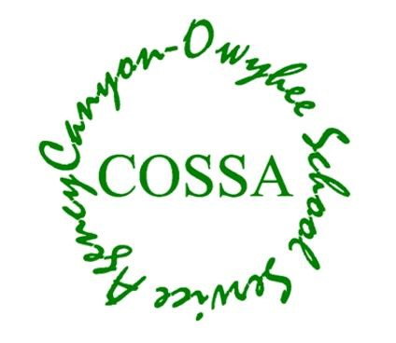
Adult, Evening &
Industry Workforce Training
CLASS: EMT Class
DAYS: Monday and Wednesdays
TIME: 5:00 to 9:00 PM
INSTRUCTOR: Scott Webb, Paramedic
STARTING: January 22nd 2024
COST: $1250
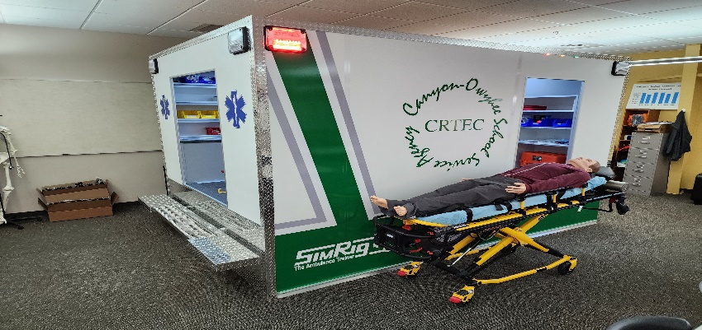

To Register call or email
Scott Webb, Short-Term Training Coordinator (208) 482-6074 ext. 1017 webbs@cossaschools.org
COSSA
109 Penny Lane
Wilder, ID 83676

